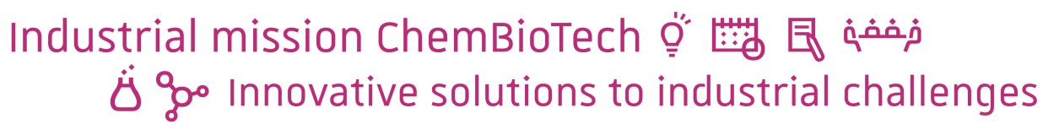

Launched in 2014 by the ECPM and the ESBS, the ChemBioTech diploma (Chemistry and Biotechnologies) trains trilingual engineers in 4 disciplinary fields: biology, molecular chemistry, chemical and biotechnological engineering and bio-analytical sciences.

This unique combination of skills is now at your disposal to sustain your development of new technologies and solve industrial problems in the areas of environment, health and cosmetics.

The industrial mission is a problem-solving pedagogical exercise run by a student team of 5 to 7 engineering students, including a project manager.

Your team will analyze your industrial issue, make a bibliographical study, draft specifications, search and select the most suitable concepts and study their technical and economic feasibility and draw a project outline.
The team is supervised by:
- your enterprise regarding technical aspects
- a university professor/researcher regarding scientific aspects
- a professional regarding managerial aspects

This whole work favors a multidisciplinary approach in close collaboration with your teams in the form of regular working meetings at the school, at your office or remotely.
Examples of subjects
Research of methods for recycling of chemical compounds (plastics, solvents, metallurgical waste)
Selection of chemical and/or biological solutions to recycling industrial process waters
Preliminary design / specifications of biological production process
Design of analytical method in production
Feasibility study of biosensors concepts
Feasibility study of chemical and biotechnological synthesis
Study of the biomass degradability/conversion by bacteria
Research and selection of bio-based materials

Time period: 6 months - from mid-Sept to mid-March
Duration: 400 to 500 work hours, including 7 collaborative work sessions of 3.5 hours each
Evaluation: written report and oral presentation

Participation to costs: a fee of 2.850€ is requested for the industrial project (including supervision, travel expenses, use of software, access to bibliographical databases, etc.).
Any other provision of service will be estimated.

YOUR ISSUE
Title
Context
(Please describe the technical and economic environment of your project)
Description of the technical issue

Goal of the project
Major focus  Concept search  Feasibility study  Optimization of process/concept |  | Draft  Enhancement of an existing solution  Technical benchmarking
Coordinates
Company name
Address
Postcode
City
Your name
Your position
Tel.
Email

Date:

Signature:

Please send this form until July, 13th to Patrick Filizian (patrick.filizian@unistra.fr)

